USER MANUAL

Product : Swimming Pool Deck
Client : Concur Design Pvt Ltd.
Mfg .Year : September 2025.

DESIGNED, DEVELOPED & MARKETED
BY

NIHVA Technologies Pvt.Ltd.

G-BLOCK, 1ST FLOOR, THERMAX CHOWK
MIDC, ABOVE RENAULT SHOWROOM
CHINCHWAD, PUNE-411019

TEL.NO. - +912066304033
EMAIL:-info@nihva.com
www.nihva.com

 | Swimming Pool Deck
Size | W 2630mmX L 6150mm
Client | Concur Design Pvt Ltd.

About This Manual  - The Motorized Retractable Swimming Pool Deck is designed to function as both a movable floor system & a deck covering for swimming pools.  - It allows user to cover the pool area when not in use, providing a safe walking surface, & retract the deck to uncover the pool with smooth, motorized motion.  - This user manual is specially designed to detail the functions and features of the Swimming Pool Deck system.  - The user manual supplied with the system may vary depending on the model or configuration.  - Please read this manual before operating the Deck to ensure safe and proper use.  - Optional components, specific features, and automatic system mentioned in this manual may not be included or may be subject to updates.  - The installation or usage environment described in this manual may differ from your actual setup. | - Descriptions are based on the system’s default settings and standard installation. Available features and additional services may vary depending on the deck model or control system.  - This user manual provides instructions for operating the Swimming Pool Deck system. Features and controls described may vary depending on the specific model.  - Images and illustrations used in this manual are based on a representative model and may differ in appearance from the actual product.  - The content of this manual may be subject to change without prior notice and may not fully reflect the final product. For the latest version of the manual, please visit the official website at https://www.nihva.com
Key Features

1.Fully motorized movement (open/close operation)
2.Sainless steel structure with anti-corrosive coating.
3.Integrated limit switch for position control.

Safety Instructions

1.Ensure all users are clear of the deck during movement.
2.Do not stand or walk on the deck while it in motion .
3.Keep hands, feet & objects away from moving parts.
4.Disconnect electrical supply before performing mainteance.
5.Operate the system only with the supplied control unit.
6.Do not overload the deck.
7.Ensure no obstruction under the deck before closing.

Product Overview

This system combines durability, style, and convenience, making it ideal for both residential and commercial spaces. Designed with a modular approach, the system ensures smooth operation and reliable performance.

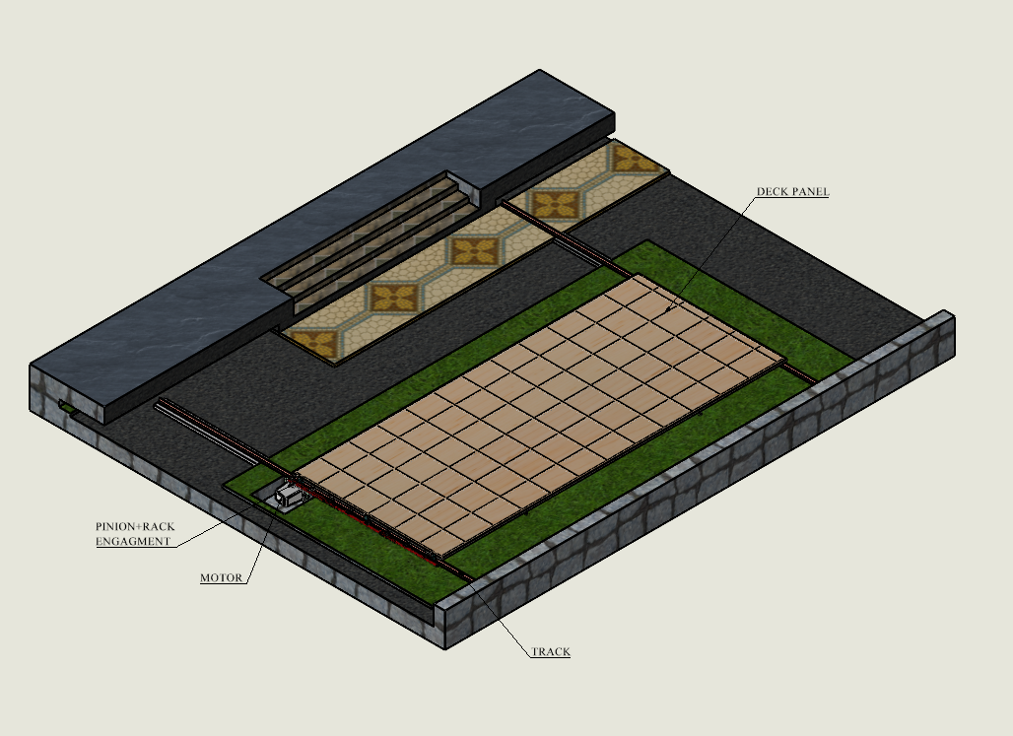

COMPONENTS :  - Features or options may differ depending on the model.  - The items marked as optional may not be provided or may be provided in different locations. | 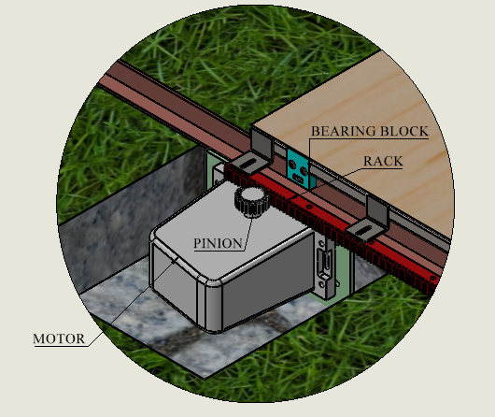

Component

Item No. | Name | Description
1. | Guide Rails | Stainless Steel Track for smooth linear motion.
2. | Bearing Block | Bearing Block used for support and Guide the bearing when it is in movement or as an working conditions.
3. | Motor drive unit | Nice 1.5T Motor for driving the rack and pinion mechanism with limit switch control, that moves the panels.
4. | Rack Support | Rack support used for support rack.
5. | Control Panel | Electrical encloser with forward/reverse selector.
6. | Remote | Control the motor motion forward & reverse.
7. | Safety Limit Switches | Prevent over travel at both ends of deck motion.
8. | Support frame | Stainless steel base structure for deck support.

Technical Specifications

SR.NO | Parameter | Specifications
1. | Power supply | 230V/240V 50HZ AC
2. | Motor | 1.5 T Nice
3. | Drive Type | Rack & Pinion
4. | Control | Forward/Reverse push button + Emergency stop
5. | Deck Material | Stainless Steel
6. | Operating Speed | 5-6 Min

Operation Instructions :
Pre-Check:
Ensure bearing blocks are lubricated.
Check for loose bolts, weld cracks, or misalignment.
Clear any obstructions from the roof path.
Opening/Closing:
Press the switch/remote for opening or closing.
During Use:
Do not overload or stand on the roof panel while in motion.

Safety Guidelines :
1.Never stand, sit, or place heavy objects on the roof panel during movement.
2.Ensure hands, tools, and clothing are away from bearing blocks, support tubes, and corner joints while opening or closing.
3.Operate the roof only using the designated switch or remote. Do not force movement manually on motorized systems.
4.Turn off the power supply during maintenance or repair to prevent accidental movement.

Maintenance Checklist :
1.Clean dust and debris from bearing blocks and moving parts.
2.Inspect locking mechanism for proper function.
3.Lubricate bearing blocks and sliding mechanisms.
4.Verify that electrical connections (if motorized) are secure and dry.

